Reference guide: trade secrets in 2026 – how to effectively protect a company’s confidential information?
Summary
- Introduction
- Information protected by trade secret law
- Reasonable protection measures
- Managing risks relating to employees and business partners
- Protecting trade secrets in legal proceedings
- Interaction with patents, other intellectual property rights and the GDPR
- Conclusion
- Q&A
Introduction
Client files, algorithms, manufacturing processes, business strategies, research data or terms negotiated with suppliers: a significant part of a company’s value lies in information that is not intended to be made public.
Since Law No. 2018-670 of July 30, 2018, which transposed Directive (EU) 2016/943, French law has provided specific protection for trade secrets. Unlike a trademark or a patent, this protection does not depend on any filing or registration.
A company must therefore be able to demonstrate that the information concerned meets the legal requirements and that it has actually taken measures to preserve its confidentiality.
In practice, effective protection requires anticipation: identifying sensitive information, controlling its circulation and keeping evidence of the measures implemented.
Information protected by trade secret law
Under Article L. 151-1 of the French Commercial Code, information is protected where three cumulative conditions are met.
It must:
- not be generally known or readily accessible to persons familiar with this type of information;
- have actual or potential commercial value because it is secret;
- be subject to reasonable protection measures, having regard to the circumstances.
Information therefore does not benefit from the regime merely because the company labels it as “confidential”.
However, the value of the information must derive, at least in part, from its secret nature. Information that is already public, commonplace or easily accessible does not automatically qualify for protection.
Trade secret law also does not prohibit every form of acquisition of information. Observing or studying a product made available to the public may, in certain circumstances, constitute a lawful means of obtaining information.
Reasonable protection measures
The third condition under Article L. 151-1 is often a decisive issue in litigation.
The law does not impose a single protection mechanism. The measures must be adapted to the nature of the information, its value and the risks to which it is exposed.
Identifying and classifying information
Not all internal information requires the same level of protection.
A company may, in particular, distinguish between ordinary internal information, confidential information and particularly sensitive data whose disclosure could directly affect its competitiveness.
This mapping exercise makes it possible to tailor security measures and access rights accordingly.
Limiting access
The “need-to-know” principle is an essential tool. This principle consists in restricting access to confidential information to only those individuals who genuinely need it in order to perform a specific task. In practice, each person involved should have access only to the information strictly necessary for their role in the project.
Information presented as strictly confidential but made indiscriminately accessible to all employees or to numerous service providers will be more difficult to protect. This requirement to control access to sensitive information forms part of the broader need to implement concrete confidentiality protection measures.
Depending on the circumstances, the company may implement:
- individualised access rights;
- authentication measures adapted to the sensitivity of the information;
- traceability of logins or downloads;
- restrictions on certain file transfers;
- prompt revocation of access when an employee or service provider leaves.
Preserving evidence
Simply marking information as “confidential” is a useful indication, but it is not sufficient on its own.
Protection generally relies on a coherent set of measures, including contractual clauses, internal policies, IT security, access restrictions and employee awareness.
Timestamping tools may also be used. An e-Soleau, for example, can establish the existence of specific content on a given date. However, it does not, by itself, demonstrate that all three conditions required for trade secret protection are met.
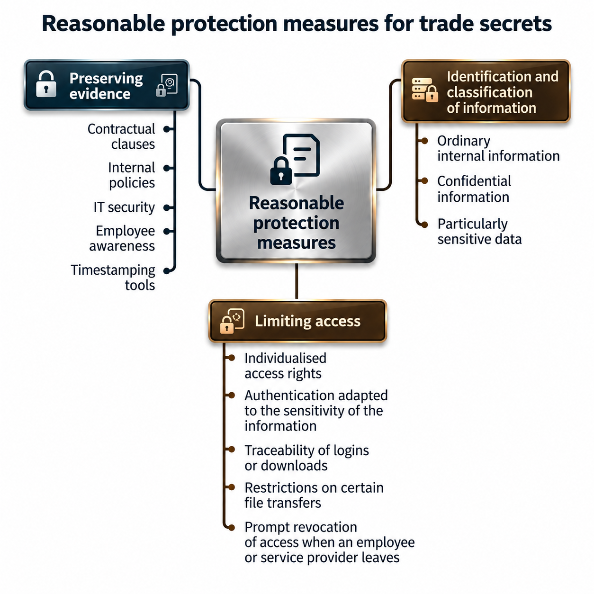
Managing risks relating to employees and business partners
Strategic information generally circulates among employees, advisers, suppliers, subcontractors and business partners. Its protection must therefore combine technical, contractual and organisational measures.
Confidentiality undertakings
An effective non-disclosure agreement (NDA) should be tailored to the project concerned and may notably specify the information covered, the persons authorised to access it, the permitted purposes of use, the arrangements for storage and transmission, the duration of the obligations, as well as the conditions for returning or destroying documents.
The use of generative artificial intelligence tools may also justify specific rules designed to prevent confidential data from being entered into services that may retain or transmit such information.
Employee departures
The departure of an employee who has access to strategic information is a particularly sensitive period.
An offboarding procedure may provide for the deactivation of access rights, the return of equipment, checks for unusual transfers and a reminder of any continuing confidentiality obligations.
For example, a file containing the prices negotiated with each client, profit margins and renewal dates will be easier to protect as a trade secret if access to it was restricted and documented than if it was freely available in a shared folder.
Protecting trade secrets in legal proceedings
Trade secret protection does not constitute an absolute obstacle to the production of evidence.
The right to evidence
In a judgment of February 5, 2025 (French Supreme Court, Commercial Chamber, February 5, 2025, No. 23-10.953), the French Supreme Court ruled on the production, in the course of judicial proceedings, of a document protected by trade secret law in order to establish alleged acts of unfair competition. It reiterated that the right to evidence may justify the production before a court of information protected as a trade secret, provided that such production is indispensable to the exercise of that right and that the interference with the trade secret is strictly proportionate to the aim pursued.
A party seeking disclosure of confidential documents must therefore be able to demonstrate their relevance and necessity.
Confidentiality during legal proceedings
Article L. 153-1 of the French Commercial Code allows the court to tailor the disclosure of sensitive information.
In particular, the court may examine a document on its own, restrict its disclosure, require a summary version, limit access to certain persons, or order that hearings be held in private.
These mechanisms make it possible to reconcile the requirements of litigation with the preservation of confidentiality.
Measures in the event of misappropriation
Where a trade secret infringement is established, the court may, in particular, prohibit the use or disclosure of the trade secret, order the delivery up or destruction of certain documents, and award damages.
Compensation may take into account the losses suffered, the profits made by the infringer, and the investment costs saved as a result of the unlawful use of the information.
Pursuant to Article L. 152-2 of the French Commercial Code, an action relating to the misappropriation of a trade secret is subject to a five-year limitation period from the date on which the lawful holder became aware, or should have become aware, of the last act giving rise to the misappropriation.
Interaction with patents, other intellectual property rights and the GDPR
Choosing between trade secret protection and patent protection
Patents and trade secrets follow different approaches.
Patent protection requires disclosure of the invention in exchange for a temporary monopoly. Trade secret protection, by contrast, allows information to remain confidential for as long as the legal requirements continue to be met.
The choice depends in particular on the risk of reverse engineering, the economic lifespan of the innovation and the company’s ability to maintain confidentiality over time.
These mechanisms may also be complementary: a patented invention may be accompanied by undisclosed know-how.
Combining trade secret protection with other forms of protection
The same asset may fall within several legal regimes. Software, for example, may be protected by copyright, while certain data, methods or technical information remain confidential.
Where appropriate, the protection strategy should therefore combine intellectual property rights, contractual arrangements and confidentiality measures.
Interaction with the GDPR
Trade secret protection does not automatically override the rights granted under the General Data Protection Regulation (GDPR).
In the Dun & Bradstreet Austria judgment of February 27, 2025 (CJEU, C-203/22), the Court of Justice examined the information that must be provided to a person affected by an automated decision.
The judgment illustrates the need to strike a balance between the effective exercise of rights under the GDPR and the protection of trade secrets or third-party rights.
Conclusion
Trade secret protection is a flexible tool for safeguarding information that is not necessarily covered by a registered intellectual property right.
However, this flexibility comes with evidentiary requirements. A company must be able to demonstrate that the information was genuinely secret, that it had value because of its secrecy, and that it was subject to reasonable protection measures.
Identifying critical information, controlling its circulation and preparing evidence in advance can therefore significantly strengthen its protection in the event of litigation.
Dreyfus Law Firm assists its clients in managing complex intellectual property cases, offering personalized advice and comprehensive operational support for the complete protection of intellectual property.
Dreyfus Law Firm works in partnership with a global network of attorneys specializing in Intellectual Property.
Nathalie Dreyfus, with the support of the entire Dreyfus team
Q&A
Does information need to be embodied in a document in order to be protected?
No. Trade secret protection may cover know-how, a method, a process or information that is not necessarily formalised in a single document. However, the company must be able to identify with sufficient precision the information for which it claims protection.
Can trade secret protection prevent a former employee from using their professional experience?
No. Trade secret law does not allow a company to appropriate the skills, experience or general knowledge acquired by an employee during their career. It does, however, protect information that specifically meets the legal requirements for trade secret protection.
Can trade secret protection apply to information disclosed to several business partners?
Yes, provided that its circulation remains controlled and that appropriate measures govern access to and use of the information. The fact that information is shared does not automatically cause it to lose its secret nature, as long as it is not generally known or readily accessible.
Can a company claim trade secret protection over information independently discovered by a competitor?
In principle, trade secret law does not prevent the independent discovery or creation of the same information. Protection is primarily aimed at the unlawful acquisition, use or disclosure of the trade secret held by the company.
How can confidential information be protected during a fundraising round or a merger and acquisition transaction?
It is advisable to organise the disclosure of sensitive information progressively, restrict access to the persons concerned and govern its use through appropriate confidentiality undertakings. The use of a secure data room can also help document access and exchanges.

